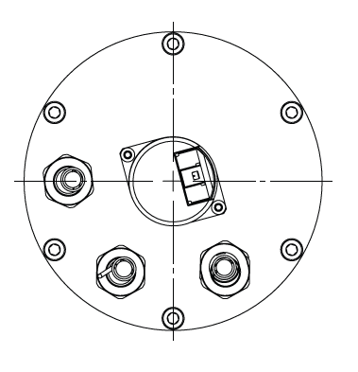
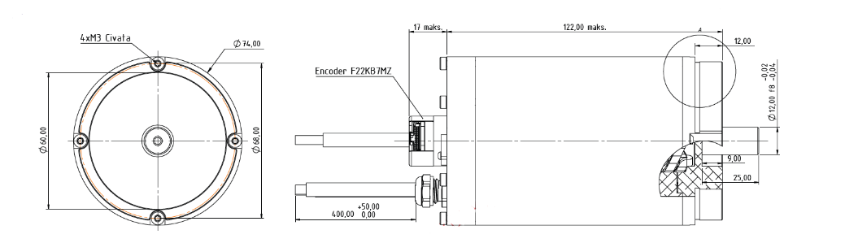
1.5 kW 270 V High Perf. Servo Motor
Basic Motor Parameters
Rated Power | W | 1500
Rated Speed | rpm | 12000
Rated Torque | Nm | 1.25
Rated Current | A | 7.1
Rated Voltage | V | 270
No-Load Speed | rpm | 13000
Max. Efficiency | % | 90
Electrical Parameters
Number of Phases |  | 3
Number of Poles |  | 4
Torque Constant (KT) | Nm/A | 0.175
Back EMF Constant (KE) | Vs/rad | 0.180
Terminal Resistance Phase to Phase (±%10) | mΩ | 760
Terminal Inductance Phase to Phase (±%30) | mH | 1100
Thermal Data
Ambient Temperature | °C | -40...+85
Max. Winding Temperature | °C | +155
Physical Parameters
Outer Diameter | mm | 74
Shaft Diameter | mm | 12
Max. Lenght | mm | 167
Weight | gr | ~1300
Motor Connection
U | RED CABLE
V | WHITE CABLE
W | BLACK CABLE
Sensor Connection
1 | GND
2 | VDC +
3 | Z’
4 | Z
5 | B
6 | B’
7 | A’
8 | A
9 | HALL A
10 | HALL B
11 | HALL C
Connector Articles
Power | M10 CABLE GLAND
Signal | Molex 501330-1100

